For Rent

1488 Villa Piña Way #201

2 bed 1.5 bath 900ft2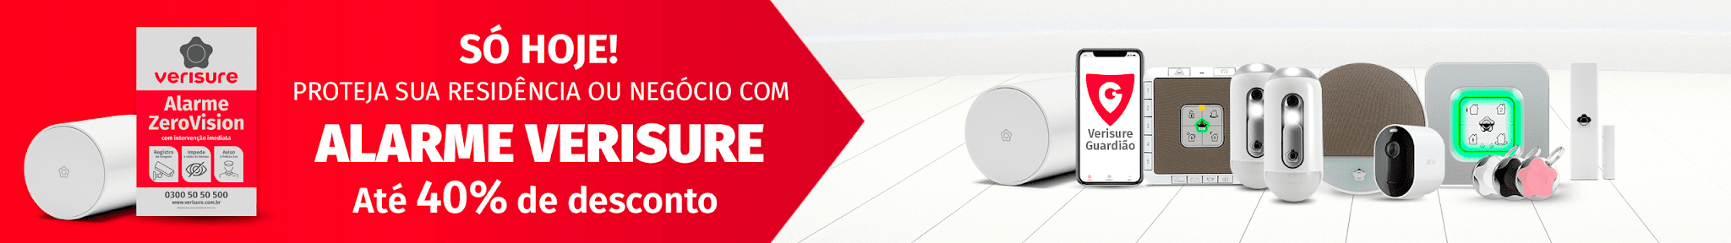

$1,550 Per Month

Spanish-style condo in great location

Won’t last! Available June 1

Contact Claire Vasquez @ (double-check cell #)

[adrendo](https://msft-ssp-useast.adnxs.com/click2?e=wqT_3QKjAfBDowAAAAMAxBkFAQiDr_m_BhC2kZCml8fozR4YqPGCif_FrZhlIIWApBAomAIwuGg4kQRAovS07AFI8opOUABaA1VTRGIBBZBoAXABeJmgZ4AByrsFiAEBkAECmAEFoAECqQEqGmt_Z3uEP7EBEQoouQEAAACAPQq3P8EVHgDJFQo82AGOvQLgAQDwAdWvBfgBAA../s=7fa4075e8e52367030e5a05cc37f22661d81bcbf/bcr=AAAAAAAA8D8=/pp=0.01/bn=89546/clickenc=https%3A%2F%2Ftrace.mediago.io%2Fju%2Fic%3Ftn%3Dfd2c78e45533ef29df88e75fbc16275a%26trackingid%3Db4323818ae5e164190ba940d928f2a49%26acid%3D21689%26data%3DIhKI2LfXSWQNdAU4vSaPqWVc0HG28zI0pTmqEYd9c6zAg_Na-B822K0gEn1QJ_4FPFZuYGMFB4CHKLELXwagCz6bNB7hSr8ls8PYEZmxv-ThQoEVYtjCCE8ZJQO6o6zSX1zP6ro7iDLk7L732pEfh4b-Kgs-R_rqye3zLuouZ-C3TUE15NMvmOzJ9SSBuTB3z2AhfA4PzOlj28AX4Z1FeemCSBt-5MvwrPncesUQM6koLXQxoDpvwXB7BgM6JdPyx3OJcB_FJED72QezbCTcm7FYZDPSC0M3DvjvVjkiXnWizcTbGoCs1dJjxn60hTh5z044Xf3uKmzSWjs1BM_e42lw2Bm5hjZAb6PnbhoClPjENE0o-cpvoQo6KnXkqm0ITDxEeMpg42qHSIgwYe5Rr8AD71H4piX1Ukq9Kqj_GnA_48BpMq9l5bUvxHGviMa1jcDGZgqf7v23_LdQ73_9tTDYz0odLLewLhAL3KEUTz8CYutSgkgBN50UBX9FX1VBeWACzqYgXE3t-iNKhP8-aPair8WDDoEh3CkRwtasZnNOI8eXdybIrkFCrqbJmx4ALZYmk-CX-cL_-GgAXinPaNQeDRJuhRz1MZkHt7W_fEnW8g5e3dMO7bIBMaKSqhvuy3GPSR0c0rIMeQ106BWXIN73VxjYQfg8_2DQeFATxHX9TzbN3AUq5TsdhjCD9aNtwMywbdyVfhJGOooZ8_VXPMrTnwBruztS0q4xn8nlJfV7dP1g_BXcaF_2gHWycwxVV1_P3-ViJRxOO4saoXA92qq6JQZxyL19sRbPMFKSarHfcctEdcrYrBLwFmW_BBUiUzcSE37cYiguxLsqZt7aEr0NC-QA1R-peJBmnWR2LwbLebYXWJUkDcaswEIa7O4fIiuNnL-x4y2LCjzfJ-1YleylmLF4-pQZ9bTWBzhp_YhMtQz9XshHOY2PjM8Mk1A0hXv7Is6nju5ea2HdGTxa4lJfks09gai5CMN9ijNGREemBOjkLdLDYnbS-o2n2q39XYJieTeAkVdD9vOEj-FbHsW229e7RqO6lIUQrxcGC3sTTB0f5_e49tVwIOT022W9WW5RUy5AZcTXl94bisJUTdl__Tt9tYvOcF35Rr09CpXpr2FfrT24yXYgOrJBBilIJyS983WalQI-L2LWpTDXrah6FD80hH-ppdx78xiabBVu99tLDbvQxYPTlN6y0XxkbfHqL1sAsY476HqVOOH4LpbQ9C_gJIObikAOrSEKO2juiU0t8h5fsFUjRDYoPAaUiv29vewNWS8kbOZSCJcA2H__uVgflpDe8yzZkpz22kvIJG9vrMQ_hsWE0WoljClm2AshMVbrPwF7ou9G0mCqiAvfxbQgp-AjLwCqUgYPQtQprr1osbI_dY8fBOdQuQUsoj2O466VVV1GGtHg4g_uVCRPkXsxN6RfqXIK2r0y7gTYfEBuedD6ilwGDTSdYyI8GFc50DsB0E9cNCEUPn5CwPdolG21hl8em7116kO41KRIhpINaY06RKfdNLFaf-bI9ZlJA9OlNafxP9qisIYqTksXo48dJtNos10SzHXvzl7fypVs8R1IjWV8IAiZrZIpkV7g8NQub1DGkyaQZrk80x8NMrZG_yuoCsp8Wrm6sHbWaQvzIwLnRj27cOJI8JtNWGxOd9BmlSMCA-X45avdrHG0o-cz2VzkSFwNQlUuRi55algCTDqQ9IPJ9Dxv6ZXL8gOLGdtmvF-InFTfN8qStLMakOA3LzwU83zh-TRUzh_Gbf-cau5f6E4TQPz6jKJoP6SEnOLYrv070r4OOIKGAMd2CTfc3FC3Uq1MDYlwqMDAGJyufp5k3tj054F5RqXqOXwxAkZqXDSc-KqvfIXKn3k4DdUVJk54Z3Fw70n7xP41C5QWfigUwEOKXjqNOGwTOh_7GjTWOV2tUPAnoycV_g%26uid%3D7291528113738004648%26mguid%3D800683565541a4192xnriu00m87cn08f%26ap%3D%7BAUCTION_PRICE%7D%26tid%3D%7Btid%7D%26gprice%3D1vzw7pn0Z1LudFwT8RxhX8yQNUTAgncizEkZcX9A4K8%26campaignid%3D2590824)

<https://www.verisure.com.br/lp/calculadora-pred/images/header-oferta.png>

**ABOUT VILLA PIÑA**

Beautiful grounds Dine-in kitchen Spacious bedrooms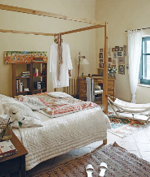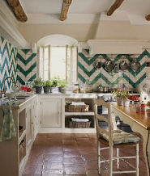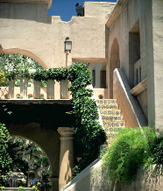

|  | David | Susan | Phil | Alisha |
| --- | --- | --- | --- | --- |
| 7 am - 10 am | Dog Kennels | Vet Tech | Dog Kennels | Vet Tech |
| 10 am - 12 pm | Cat Cages | Vet Tech | Bird House | Cat Cages |
| 12 pm - 3 pm | Vet Tech | Front Desk | Front Desk | Vet Tech |

Private but centrally located, historic Villa Piña is just moments from fine dining, shopping, and public transportation. Enjoy the best of both worlds at Villa Piña—the beauty of nature and the culture of a vibrant neighborhood.

For more information, visit us online:

[*www.villapinacondos.com*](http://www.villapinacondos.com)

**